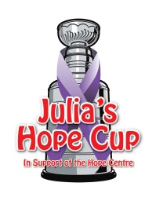
Julia’s Hope Cup 2020
KIDS MINI TOURNEY PLEDGE SHEET

This year we welcome our friends at to Julia’s Hope Cup. PenFinancial has committed to matching each $25 kids mini tourney registration fee!

All donations received go directly to support the Hope Centre.

Dear Sir or Madam,
Thank you for your pledge to help _______________________ participate in this year’s Julia’s Hope Cup. Your pledge contributes to the cost to enter the Julia’s Hope Cup hockey tournament on Feb 15th, 2020.
Thank you very much for your support.
NAME | ADDRESS | AMOUNT
PenFinancial Truly Local Kids Pledge $25

The Hope Centre: 570 King St, Welland, ON L3B 3L2 Phone: 905-788-0748 Fax: 905-788-0748
Email: Shannon at smunro@thehopecentre.net
Web: www.thehopecentre.net Charitable Registration No. 11929 0591 RT0001

